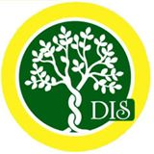

Class- Pre-Nursery Lily

THEME : Victory of good over evil VALUE : Peace

Syllabus Planner for the month of October
Subject | Topic
English | Recap of A TO R  Introduction of Letters of S,T,U, V  Pattern Writing- Zig-Zag, Waves and U shape pattern  Writing Letters of T,U,V,A,D
Maths | Writing Number : 6,8,2 and 3  Sequence Learning(1-10)
EVS | Wild animals
Rhymes | Pretty Balloons, Animals, Elephant
Art & Craft | Paste and colour  Copy Colour
Story | The Lion and the mouse
Special Days | Dussehra Celebration  Diwali Celebration
Moral Values | Peace  Victory of good over evil

