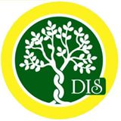

Class- Pre-Nursery

THEME : Lets do wonders by creativity VALUE : Joy

Syllabus Planner for the month of November
Subject | Topic
English | - Recap of A TO V  - Introduction of W X Y Z With help of activities  - Writing Letters W X Y Z  - Pattern Writing: Trace the path, matching fun, let’s revise(trace the lines)
Maths | - Revise(1-10)  - Writing Numbers: Tracing 1 to 10  - Worksheets related to numbers(in book)
EVS | - Pet animals
Rhymes | - Hop a little..  - Fishy fishy
Art & Craft | - Find the path  - Dot to Dot  - Cotton squab impression
Story | The Peacock and the Crane
Special Days | Children’s Day Celebration
Moral Values | Joy  Lets do wonders by creativity

